**Bancroft Education**

**The Road Forward**

**Emergency Virtual or Remote Instruction Plan 2025-2026**

**Bancroft Early Education - Moorestown**

**Bancroft at Voorhees Pediatric Facility**

**The Bancroft School - Mt. Laurel**

**Kohler Academy - Mountainside**

**INTRODUCTION**

***The Bancroft Schools***

The Bancroft School, Bancroft Early Education, Bancroft School at Voorhees Pediatric Facility and Kohler Academy, a Bancroft School are committed to adhering to guidance from the Department of Health, Center for Disease Control, and The Department of Education in relation to procedures to combat and mitigate the risk of any potential outbreak in our schools located in Camden County, New Jersey, Burlington County, New Jersey and Union County, New Jersey. Therefore, we present this document as our plan of action to maintain safe facilities, practice precautionary measures with staff and students and continue to fulfill our instructional and therapeutic obligation to students and their IEPs via remote/virtual learning.

***Purpose of Plan***

1. To establish and implement preventative and emergency measures to address the potential risk of a Pandemic/ outbreak or emergency situation to ensure the health and safety of the students, staff and families who attend and work at The Bancroft Schools.
2. To outline established education practices that ensure students are provided equitable access to IEP instruction and related therapies via remote/virtual instruction and tele-therapy sessions. To demonstrate efforts in our provision of resources to students and families and through ensuring families have the necessary tools and support to engage in remote/virtual instruction.

***Student Demographic Profile***

**The Bancroft School - Mt. Laurel**

The Bancroft School Mt. Laurel provides educational services for children ages 10 - 21 with developmental challenges. Approximately 50% of the students reside in Bancroft residence and the other approximate 50% are day students who reside at home or with other residential agencies. Transportation for day students is provided by the sending school districts or parents.

44 MD classrooms serving up to 264 students.

No ELL students at this time

**Early Education Program - Moorestown**

The Bancroft Early Education Program provides educational services for children ages 3-11. Currently all students served at the school are day students who reside at home, however at any time the school may service students who reside in a residential facility. Transportation to and from school is provided by either the sending school district or the family.

8 classrooms: 1 preschool classroom, 8 MD classrooms serving up to 72 students.

No ELL students at this time

**Bancroft at Voorhees Pediatric Facility**

Bancroft at Voorhees Pediatric Facility provides educational services for children who reside at Voorhees Pediatric Facility who require 24 hour nursing and respiratory care.

12 classrooms: 11 MD, 1 PD

Students: 60 MD, 6 PD No ELL students

**Kohler Academy, a Bancroft School**

Kohler Academy, a Bancroft School provides educational services for children ages 3-21 with developmental challenges. Currently all students reside at home and transportation is provided by the school district or family.

8 Classrooms: 7 MD, 1 PD

Students: 58 MD, 6 PD, No ELL students:

**TABLE OF CONTENTS**

**Section 1 - Preparation for Health-Related School Closure page 6**

* Bancroft Task Force
* Voorhees Pediatric Task Force
* Health Related School Closure process
* Initial Plan of Instruction during closure

**Section 2 - Remote/Virtual Instruction and Teletherapy Plans page 9**

* **The Bancroft School - Mt. Laurel**
  + Remote/Virtual Learning - Teachers
  + Behavior Analyst behavior support
  + OT, PT, SLP, Psych Services tele-therapy
  + Social Workers
* **Early Education Program - Moorestown**
  + Remote/Virtual Learning - Teachers
  + Behavior Analyst behavior support
  + OT, PT, SLP, Psych Services tele-therapy
  + Social Workers
* **Bancroft at Voorhees Pediatric Program**

Remote /Virtual Learning - Teachers

Clinical Services

Nursing

* **Kohler Academy, a Bancroft School**

Remote /Virtual Learning - Teachers

Behavior Analyst Behavior Support

OT, PT, SLP, Psych Services tele-therapy

Social Workers

**Section 3 - Facilities - Cleaning and Maintenance page 21**

**Section 4 - School Nursing Protocols page 23**

* **Monitoring for signs & symptoms of COVID-19**
* **Illness Protocols**

**Section 5 - Staff Training page 25**

* **Bancroft School, EEP and Kohler Academy**
  + Hygiene Practices
  + Intensified Cleaning and Disinfecting protocols
  + Mitigation Strategies
* **Voorhees Pediatric Facility**
* **New Staff Orientation**
* **Annual Recertifications**

**Section 6 Re-Opening page 27**

**Section 7 - Technology page 28**

**Section 8 - Provision of School Meals page 29**

**Section 9 - Communication with Families and Districts page 29**

* **Parent Contact Information**
* **Communication of a Health-Related Facility Closure**
* **Communication during a Health-Related Facility Closure**
  + The Bancroft School, Early Education Programs and Kohler Academy
  + Bancroft at Voorhees Pediatric Facility

**APPENDICES**

**SECTION 1**

**PREPARATION FOR HEALTH-RELATED OR PHYSICAL PLAN EMERGENCY FACILITY CLOSURE**

**Bancroft Task Force**

In an effort to prepare and respond to a health-related or physical plant emergency crisis, Bancroft created a Task Force composed of leaders from each service line; executive, program operations and clinical teams. The role of this task force has been to identify and address potential risks, develop and execute safety and wellness plans, respond to licensing and funding partners and to monitor data around this unprecedented event.

The formulation of our response efforts has been informed by guidelines and recommendations of federal, state and local governments, funding agencies and data analysis within our programs, all with the purpose of maintaining our commitment to quality care of the children and adults served in our programs.

Bancroft’s task force will activate and monitor the developments of the situation, in NJ, local communities and in all Bancroft programs, on a regular basis. At the onset of any health crisis, the task force will establish points of contact with the DOH and CDC as well as with other organizations (see Appendix A) to address the required inventory of supplies needed, provide training for staff, maintain weekly communication to families and provide updated directives to all service line leaders and personnel as guidelines and directives changed. All of these efforts and practices will continue until no longer necessary.

**Voorhees Pediatric Facility Task Force**

In an effort to always be prepared to prevent and/or address a potential virus outbreaks or emergency situations, Voorhees Pediatric Facility has a Clinical Task Force composed of a representative from each service department at Voorhees Pediatric Facility which addresses potential outbreaks and designs a plan of action to implement when a risk presents itself. The Task Force meets regularly to review, conduct drills and address any concerns. When activated, the task force meets daily and / or multiple times a day to address a potential risk or outbreak.

Bancroft School at Voorhees Pediatric Facility participates on this task force and collaborates with the Bancroft Task Force.

**Health-Related School Facilities Closure Process**

* In the event that The Bancroft School, Bancroft Early Education Program, Bancroft at Voorhees Pediatric Facility Program or Kohler Academy, a Bancroft School are directed by DOH or DOE to close facilities OR Bancroft determines it is in the best interest of student and staff safety to do so, the schools will implement the remote instruction plan.
* The Bancroft CCO, SVP of Children’s Services and Director of Communication will be notified.
* The school(s) which is affected by the closure will notify the Department of Education and the County Office of Education.
* Communication will be provided to staff via Realtime alert system and email.

**Plan of Instruction during facility closure**

***The Bancroft School, Early Education Program and Kohler Academy***

* Google Classrooms will be the primary vehicle for organizing and storing student lesson activities.
* All teachers and clinicians create at least two weeks of lessons, activities and individualized therapy exercises / activities to equal 4 hours instruction per day excluding lunch and recess.
* Lesson packets, activities and supplemental materials will be sent home with students on the last day of school before a facility closure, picked up by parents or mailed home.
* Lesson packets, activities and supplemental materials will continue to be updated and sent home via postal mail or email until school facility reopens.
* Where applicable, links to apps, Smartboard, Promethean Board and online activities will be sent home with students, emailed and/or incorporated into Google Classroom.
* Individualized exercises and activities developed by clinicians/therapists will be sent home with students.
* Teachers will establish full remote learning session schedules with each family. 1:1 support will be used to support instruction. Sessions will be conducted via Google Meets.
* Attendance will be taken daily. Parents will have the opportunity to notify the teacher each day that their child is well and will be participating for the day as well as sign off on the date activities that were completed.
* Parents are annually surveyed about technology access. Bancroft has/will provide technology to all families who requested assistance.
* Families were provided the contact information for their child’s school team (phone numbers, email, video-conferencing options) to ensure their ability to initiate any necessary communication during the closure for questions, assistance with lessons and guidance.

***Voorhees Pediatric Facility***

Due to the medical fragility of our students and their placement in a long term care facility, virtual and remote instruction will be provided as follows:.

* When students are placed in quarantine by the medical team at Voorhees Pediatric Facility or the school is closed by the DOH due to an outbreak, Teachers will provide synchronous / remote instruction to their students for the full four hour session on a daily basis through The Google Platform.
* A Chromebook for remote instruction and an individual bag of materials will be placed in the student’s room in the facility.
* Instruction will be based on the student’s IEP goals and objectives
* Data on goals and objectives will be collected by teachers and documented in ACE
* Lesson plans will be prepared at least for two weeks in advance by the teacher.
* Attendance will be recorded daily in Realtime
* Therapy sessions will be provided according to the child’s IEP and the guidelines outlined by the DOH for long term care facilities for delivery protocol.
* The education team will collaborate with the Nursing, Respiratory and Rehab team at Voorhees Pediatric Facility to provide the support needed for instruction.
* Families and the VPF team will be notified of school closure and updated accordingly.

**SECTION 2**

**REMOTE INSTRUCTION AND TELE-THERAPY PLANS**

**The Bancroft School**

***Remote/Virtual Learning Instruction - Teachers***

* In accordance with each student’s IEP, teachers, with the support of 1:1 aides, have created Google Classrooms as the primary vehicle for all lessons and activities. However, additional lessons, activities and compiled material resources needed for learning activities have been sent home via student backpacks, picked up by parents, emailed and/or mailed via USPS. This will be an ongoing process any time the school facility is closed.
* Teachers will schedule time with each student’s family for instructional contact, guidance, support and assessment. Teacher to student contact will be primarily through the use of Google meets, but will also be by phone and email with parents.
* Teachers will be available to students and families during school hours, Monday through Friday for additional support outside the scheduled instructional times.
* The Bancroft School will electronically survey families for technology needs. Bancroft will work with sending school districts or provide the necessary technology resources so students are able to access their education.
* For students residing in Bancroft residential programs, 1:1 staff will be deployed to provide direct, daily support of instructional activities, will collect data and be in regular contact with classroom teachers.
* For students residing in Bancroft residential programs, teachers will provide a period of daily instruction via Google Meets.
* Teachers will maintain a Weekly Student Contact form which includes communication contacts and will make available to sending districts upon request.
* Attendance is submitted through our Realtime system based on parent reporting [parents of day students will report absences to the school nurse].
* If a family is unavailable for a scheduled session, every effort will be made to reschedule.
* In situations where language is a barrier, translation services will be provided.
* If a family refuses academic sessions or misses more than 1 week of scheduled appointments, it will be documented and communicated to the sending school district and an IDT will be convened.
* Classroom Clinics among team members (teacher, 1:1, related service clinicians) will continue to be held to help problem solve and support families. It will also serve as one way to maintain communication among the school team.
* Teachers will continue to prepare IEPs for upcoming IEP meetings and participate in meetings as scheduled.
* Program Supervisors will maintain weekly contact with teachers through team meetings or individual 1:1 meetings, using Google Meets.
* All 1:1 staff will continue to support student remote instruction and clinical/related services either in person (residential students) or remotely (day students).
* 1:1 staff will support the students by participating in remote instructional lessons and teletherapy, collecting data, and assisting with developing remote learning materials.
* 1:1’s will record and provide education data to teachers on a regular basis.
* Teacher generated IEP checklists will be sent home to parents and will be used to gauge student’s progress based on parent reporting.
* Progress will be reported as regression, maintained, progress or not sure.
* We are continuing to assess our data collection processes and looking for additional methodologies for remote data collection and reporting.
* This process will continue to evolve as we improve our remote practices.
* The Bancroft Education Leadership will monitor virtual lessons and teletherapy sessions through observation as an attendee.
* Families and districts will be notified via phone or Realtime alert system when school is reopened.
* All CBI, Internships and Community Activities will be placed on hold if required by DOH and DOE and Bancroft will follow DOH and DOE guidelines to begin services again.
* For ELL students Bancroft will design and implement a bilingual program and hire certified bi-lingual teachers to ensure successful learning experiences for all students including ELL students.
* Bancroft currently contracts with Accurate Language for translating documents and providing interpretation services for our students/ families.
* Bancroft currently provides diverse instructional strategies for all students including Universal Design, Differentiated instruction, Analysis, Positive Behavior Supports, Sensory based instruction, individual, small and large group instruction which will benefit all students including ELL students

***Graduation***

* Graduation plans will follow guidelines set forth by DOE and DOH.

***Behavior Analyst behavior support***

* BCBAs will schedule a weekly time with each student’s family to provide guidance and/or training with behavioral interventions and protocols and video observations. They will record a schedule in Google calendar.
* All 1:1 staff will be deployed to support instruction, behavior and related service delivery of residential students.
* As a follow up to each contact, BCBAs will email a summary of the session to the family and cc their supervisor and classroom social worker.
* If a family is unavailable for a scheduled session, every effort will be made to reschedule.
* If a family refuses a session or misses more than a week of scheduled appointments, it will be documented.
* In situations where language is a barrier, translation services will be provided.
* Any Functional Assessments deemed critical will be scheduled at the Welsh Campus. If required by DOH, a wellness check for staff, families and students will be conducted upon arrival.
* All current individual behavior plans will be reviewed and updated based upon data analysis.
* Classroom Clinics among team members will continue to be held to help problem solve and support families. It will also serve as one way to maintain communication among the school team.
* BCBAs will continue to prepare for upcoming IEP meetings and participate in meetings.
* The supervisor will maintain weekly contact with BCBAAs through team meetings or individual 1:1 meetings, using Google Hangouts.

***OT, PT, SLP, Psych Services - Teletherapy***

* OT, PT, SLP will prepare relevant and developmentally appropriate activities and strategies related to students’ IEP goals and objectives; extent of activities will correlate with the service delivery indicated in each student’s IEP. Those materials will be sent home in student backpacks or mailed to families.
* OT, PT, SLP will create instructional therapy videos to support service delivery.
* OT, PT, SLP, psychologist will create a service delivery schedule with each family to provide direct services support and guidance via Google Meets.
* Mandated psych services will be provided via phone or Google Meets.
* OT, PT, SLP, psychologist will email a summary of the session(s) to the family weekly and cc their supervisor and classroom social worker.
* OT, PT, SLP, psychologist will be available by phone and email during school hours, Monday through Friday to provide additional support to families.
* For those students residing in Bancroft residential facilities, 1:1s will support service provision.
* If a family is unavailable for a scheduled session, every effort will be made to reschedule.
* If a family refuses a session or misses more than 1 week of scheduled appointments, the district will be notified. The team may determine the need for a meeting.
* SEMI forms will be completed by the therapist/clinician and submitted in person or electronically to the administrative assistant who will send them to the district SEMI Coordinator.
* If a family is in need of additional support, arrangements can be made for an in person session at the Welsh campus. If required by the DOH, wellness checks will be conducted for staff, students and family members upon arrival.
* In situations where language is a barrier, translation services will be provided.
* OT, PT, SLP and the school psychologist will continue to prepare for and participate in IEP meetings as regularly scheduled.
* Supervisor will maintain weekly contact with clinicians/therapists through team meetings or individual 1:1 meetings, using Google Meets.

***Social Workers***

* School Social Workers will continue to schedule all required and requested meetings for IEP teams.
* School Social Workers will continue to vet questions and concerns from parents and school districts.
* School Social Workers will assist in accessing all necessary support for families during school closure, to include: translation services, access to technology, assurance of school breakfast and lunch for families in need, etc.
* Social Workers will be available to families by phone, email or Google Meets during school hours, Monday through Friday.
* Social Workers will document all communication with families and districts on the weekly communication form.
* Social Worker will send out weekly communication forms to districts on an as needed basis.

**The Bancroft Early Education Program**

***Remote/Virtual Learning Instruction - Teachers***

* In accordance with each student’s IEP, teachers, with the support of 1:1 aides, have created Google Classrooms as the primary vehicle for all lessons and activities. However, additional lessons, activities and compiled material resources needed for learning activities will be sent home via student backpacks, picked up by parents, emailed and/or mailed via USPS. This will be an ongoing process any time the school facility is closed.
* Teachers will schedule time with each student’s family for instructional contact, guidance, support and assessment and progress monitoring. These contacts will be done via the following methods: phone call, email, Google Meet
* Teachers will be available to students and families during school hours, Monday through Friday for additional support outside the scheduled instructional times.
* Teachers will maintain a schedule of contacts and provide and complete the weekly communication form to include all communication attempts, emails, data collection etc.
* Attendance is submitted through our Realtime system, teachers and clinicians will be in contact with the social worker to document absences and communicate with the sending school district.
* If a family is unavailable for a scheduled session, every effort will be made to reschedule.
* In situations where language is a barrier, translation services will be provided, this will be arranged through the social worker.
* If a family refuses academic sessions or misses more than 1 week of scheduled appointments, it will be documented and communicated to the sending school district, a meeting will be called if deemed necessary by the school district.
* Classroom Clinics among team members (teacher, 1:1, related service clinicians) will continue to be held to help problem solve and support families. It will also serve as one way to maintain communication among the school team.
* Teachers and clinicians will continue to prepare IEPs for upcoming IEP meetings and participate in meetings virtually.
* Program Leadership will maintain weekly contact with teachers through virtual team meetings or individual 1:1 meetings, using Google Meet.
* Families and districts will be notified via phone or Realtime alert system when school is reopened.
* Teachers and Clinicians will collect data through parent report (email, phone, google hangout, photos/videos of student work) as well as, direct observation through Google Meet
* Teacher generated IEP checklists, detailed instructions and explanations of activities and data sheets have been sent home to parents and will be used to gauge student’s progress based on parent reporting and teacher observation
* Progress will be reported as prompted or independent. Mastery of objectives will be indicated as well.
* This process will continue to evolve and improve as staff and parents learn what it means to work in a virtual environment
* The Bancroft Education Leadership will monitor virtual lessons and teletherapy sessions through observation as an attendee.
* Teachers may create instructional therapy videos on our YouTube channel or Google Classroom Platform to support service delivery.
* Google Classroom may be used to provide a virtual classroom for students
* No ELL students are enrolled in the program therefore no ELL services are provided.
* All CBI and Community Activities will be placed on hold if required by DOH and DOE and Bancroft will follow DOH and DOE guidelines to begin services again.

***Behavior Analyst behavior support***

* BCBAs will be available to schedule a weekly time with each student’s family to provide guidance and/or training with behavioral interventions and protocols and video observations. They will record a schedule in Google calendar.
* All communication with families and districts will be documented on the weekly communication form for each student.
* All 1:1 staff will be deployed to support instruction, behavior and related service delivery of residential students.
* If a family is unavailable for a scheduled session, every effort will be made to reschedule.
* If a family refuses a session or misses more than a week of scheduled appointments, it will be documented, social workers will be notified if an IDT is deemed necessary.
* In situations where language is a barrier, translation services will be provided, this will be arranged through the social worker.
* Functional Assessments may be scheduled at the Moorestown Campus. If required by the DOH, a wellness check for staff, families and students will be conducted upon arrival.
* All current individual behavior plans will be reviewed and updated if needed based upon data analysis.
* Classroom Clinics among team members will continue to be held to help problem solve and support families. It will also serve as one way to maintain communication among the school team.
* BBCAs will continue to prepare for upcoming IEP meetings and participate in meetings.
* Supervisor/Principal will maintain weekly contact with BCBAs through team meetings or individual 1:1 meetings, using Google Meets.
* Behavior Analysts may create instructional therapy videos on our YouTube channel or Google Classroom to support service delivery.
* For ELL students Bancroft will design and implement a bilingual program and hire certified bi-lingual teachers to ensure successful learning experiences for all students including ELL students.
* Bancroft currently contracts with Accurate Language for translating documents and providing interpretation services for our students/ families.
* Bancroft currently provides diverse instructional strategies for all students including Universal Design, Differentiated instruction, Analysis, Positive Behavior Supports, Sensory based instruction, individual, small and large group instruction which will benefit all students including ELL students

***OT, PT, SLP, Psych Services - Tele-therapy***

* OT, PT, SLP will prepare relevant and developmentally appropriate activities and strategies related to students’ IEP goals and objectives; extent of activities will correlate with the service delivery indicated in each student’s IEP. Materials will be sent home, picked up by family or mailed as needed.
* OT, PT, SLP may create instructional therapy videos on our YouTube channel to support service delivery.
* OT, PT, SLP, will create a service delivery schedule for each family to provide direct services support and guidance via Google Meets that matches the mandates in the student IEP and the student in school schedule.
* Mandated psych services will be provided via Google Meets to the greatest extent possible. Phone and email may be considered as well.
* OT, PT, SLP, will complete the weekly communication form for each student documenting all communication between therapist family and district as well as data and progress notes.
* OT, PT, SLP, psychologist will be available by phone and email during school hours, Monday through Friday to provide additional support to families.
* For those students residing in Bancroft residential facilities, 1:1s will support service provision.
* If a family refuses a session or misses more than 1 week of scheduled appointments, the district will be notified. The team may determine the need for a meeting.
* SEMI forms will be completed by the therapist/clinician and submitted in person or electronically to the administrative assistant who will send them to the district SEMI Coordinator.
* In situations where language is a barrier, translation services will be provided, this will be set up through the social worker..
* OT, PT, SLP will continue to prepare for and participate in IEP meetings as regularly scheduled.
* Attendance will be maintained on an individual basis and a record will be kept of sessions that need to be made up.
* Program Leadership will maintain weekly contact with clinicians/therapists through team meetings or individual 1:1 meetings, using Google Meets.
* Clinicians will continue to complete daily attendance logs, clinical notes, semi forms and data collection on a daily basis.

***Social Workers***

* School Social Workers will continue to schedule all required and requested meetings for IEP teams.
* School Social Workers will continue to vet questions and concerns from parents and school districts.
* School Social Workers will assist in accessing all necessary support for families during school closure, to include: translation services, access to technology, assurance of school breakfast and lunch for families in need, etc.
* Social Workers will be available to families by phone, email or Google Meet during school hours, Monday through Friday.
* Social Workers will document all communication with families and districts on the weekly communication form.
* Social Worker will send out weekly communication forms to districts on an as needed basis.

***Voorhees Pediatric Facility:***

***Remote Learning***  (when school is closed and students are in quarantine)

● Remote instruction will be provided by teachers via Chromebooks/video conferencing (Google Meets) daily to students when in person instruction is not permitted. Students will remote live/synchronized learning into the classroom program for the full four hours.

● Paras will provide support for remote instruction, attendance and activity and material preparation.

● Therapies (OT, PT, ST) will be provided remotely when in person sessions are not permitted. Therapists will collaborate with the VPF medical team to ensure sessions/ recommendations are followed.

● Documentation will consist of data collection, logs, and SEMIs (therapies).

● Each child will have their own bag of school supplies and tactile items to use with the prepared lessons.

● Staff will implement synchronized learning via remote when required by the medical team and as dictated by DOH restrictions per long term care facilities

* All CBI, Internships and Community Activities will be placed on hold if required by DOH and DOE and Bancroft will follow DOH and DOE guidelines to begin services again.
* For ELL students Bancroft will design and implement a bilingual program and hire certified bi-lingual teachers to ensure successful learning experiences for all students including ELL students.
* Bancroft currently contracts with Accurate Language for translating documents and providing interpretation services for our students/ families.
* Bancroft currently provides diverse instructional strategies for all students including Universal Design, Differentiated instruction, Analysis, Positive Behavior Supports, Sensory based instruction, individual, small and large group instruction which will benefit all students including ELL students

***Communication with Families, Districts and Voorhees Pediatric Facility***

● Districts will be contacted to initiate the Plan.

● Families will be notified of alternate plans of providing educational and therapy services. Therapies will be tracked on SEMI.

● Attendance will be tracked in Realtime and districts will be notified if a student is absent 5 consecutive days due to illness.

● Families and districts will be notified via phone, Realtime or email when the classroom program resumes.

***IEP/Re-evaluation /IDT Meetings***

● Principal and/or Education Supervisor will coordinate with scheduling meetings with districts and staff

● Teachers and Therapists will attend IEP meetings via videoconferencing/phone either through Google Meets or Zoom (depending on district request)

● Teachers and Therapists will continue to provide written documentation and be available for IDT meetings (via Google Meets)

● Principal and/or Education Supervisor will collaborate with Voorhees Pediatric Facility Medical Team on medical status of children, remote learning/ therapy implementation /schedules and IDT team meetings.

***VPF Facilities:***

● Voorhees Pediatric Facility is responsible for their own facility maintenance

***VPF Nutrition Plan:***

● VPF nursing provides the students with their nutrition (G or J tube feedings)

***Graduation:*** Will follow guidelines set forth by DOE and DOH

***Kohler Academy, a Bancroft School***

***Remote/Virtual Learning Instruction - Teachers***

* In accordance with each student’s IEP, teachers, with the support of 1:1 aides, have created Google Classrooms as the primary vehicle for all lessons and activities. However, additional lessons, activities and compiled material resources needed for learning activities have been sent home via student backpacks, picked up by parents, emailed and/or mailed via USPS. This will be an ongoing process any time the school facility is closed.
* Teachers will schedule time with each student’s family for instructional contact, guidance, support and assessment and progress monitoring. These contacts will be done via the following methods: phone call, email, Google Meets.
* Teachers will be available to students and families during school hours, Monday through Friday for additional support outside the scheduled instructional times.
* Teachers will maintain a schedule of contacts and provide and complete the weekly communication form to include all communication attempts, emails, data collection etc.
* Paras will assist in the assembly of student packets and participate in scheduled virtual instruction sessions.
* Attendance is submitted through our Realtime system, teachers and clinicians will be in contact with the social worker to document absences and communicate with the sending school district.
* If a family is unavailable for a scheduled session, every effort will be made to reschedule.
* In situations where language is a barrier, translation services will be provided, this will be arranged through the social worker.
* If a family refuses academic sessions or misses more than 1 week of scheduled appointments, it will be documented and communicated to the sending school district, a meeting will be called if deemed necessary by the school district.
* Classroom Clinics among team members (teacher, 1:1, related service clinicians) will continue to be held to help problem solve and support families. It will also serve as one way to maintain communication among the school team.
* Teachers and clinicians will continue to prepare IEPs for upcoming IEP meetings and participate in meetings virtually.
* Program Leadership will maintain weekly contact with teachers through virtual team meetings or individual 1:1 meetings, using Google Meets.
* Families and districts will be notified via phone or Realtime alert system when school is reopened.
* Teachers and Clinicians will collect data through parent report (email, phone, google meets, photos/videos of student work) as well as, direct observation through Google Meets
* Teacher generated IEP checklists, detailed instructions and explanations of activities and data sheets will be sent home to parents and will be used to gauge student’s progress based on parent reporting and teacher observation
* Progress will be reported as prompted or independent. Mastery of objectives will be indicated as well.
* This process will continue to evolve and improve as staff and parents learn what it means to work in a virtual environment
* The Bancroft Education Leadership will monitor virtual lessons and teletherapy sessions through observation as an attendee.
* Teachers may create instructional therapy videos on our YouTube channel or Google Classroom Platform to support service delivery.
* Google Classroom may be used to provide a virtual classroom for students
* All CBI, Internships and Community Activities will be placed on hold if required by DOH and DOE and Bancroft will follow DOH and DOE guidelines to begin services again.
* For ELL students Bancroft will design and implement a bilingual program and hire certified bi-lingual teachers to ensure successful learning experiences for all students including ELL students.
* Bancroft currently contracts with Accurate Language for translating documents and providing interpretation services for our students/ families.
* Bancroft currently provides diverse instructional strategies for all students including Universal Design, Differentiated instruction, Analysis, Positive Behavior Supports, Sensory based instruction, individual, small and large group instruction which will benefit all students including ELL students

***Behavior Analyst behavior support***

* BCBAs will be available to schedule a weekly time with each student’s family to provide guidance and/or training with behavioral interventions and protocols and video observations. They will record a schedule in Google calendar.
* All communication with families and districts will be documented on the weekly communication form for each student.
* If a family is unavailable for a scheduled session, every effort will be made to reschedule.
* If a family refuses a session or misses more than a week of scheduled appointments, it will be documented, and social workers will be notified if an IDT is deemed necessary.
* In situations where language is a barrier, translation services will be provided, this will be arranged through the social worker.
* Functional Assessments may be scheduled at the Mountainside. If required by the DOH a wellness check for staff, families and students will be conducted upon arrival.
* All current individual behavior plans will be reviewed and updated if needed based upon data analysis.
* Classroom Clinics among team members will continue to be held to help problem solve and support families. It will also serve as one way to maintain communication among the school team.
* BAs will continue to prepare for upcoming IEP meetings and participate in meetings.
* Supervisor/Principal will maintain weekly contact with BAs through team meetings or individual 1:1 meetings, using Google Meets.
* Behavior Analysts may create instructional therapy videos on our YouTube channel or Google Classroom to support service delivery.

***OT, PT, SLP, Psych Services - Tele-therapy***

* OT, PT, SLP have prepared relevant and developmentally appropriate activities and strategies related to students’ IEP goals and objectives; extent of activities will correlate with the service delivery indicated in each student’s IEP. Materials will be sent home, picked up by family or mailed as needed.
* OT, PT, SLP may create instructional therapy videos on our YouTube channel to support service delivery.
* OT, PT, SLP, have created a service delivery schedule for each family to provide direct services support and guidance via Google Meet that matches the mandates in the student IEP and the student in school schedule.
* Mandated psych services will be provided via Google Meet to the greatest extent possible. Phone and email may be considered as well.
* OT, PT, SLP, will complete the weekly communication form for each student documenting all communication between therapist family and district as well as data and progress notes.
* OT, PT, SLP, psychologist will be available by phone and email during school hours, Monday through Friday to provide additional support to families.
* If a family refuses a session or misses more than 1 week of scheduled appointments, the district will be notified. The team may determine the need for a meeting.
* SEMI forms will be completed by the therapist/clinician and submitted in person or electronically to the administrative assistant who will send them to the district SEMI Coordinator.
* In situations where language is a barrier, translation services will be provided, this will be set up through the social worker..
* OT, PT, SLP will continue to prepare for and participate in IEP meetings as regularly scheduled.
* Attendance will be maintained on an individual basis and a record will be kept of sessions that need to be made up.
* Program Leadership will maintain weekly contact with clinicians/therapists through team meetings or individual 1:1 meetings, using Google Meets.
* Clinicians will continue to complete daily attendance logs, clinical notes, semi forms and data collection on a daily basis.

***Social Workers***

* School Social Workers will continue to schedule all required and requested meetings for IEP teams.
* School Social Workers will continue to vet questions and concerns from parents and school districts.
* School Social Workers will assist in accessing all necessary support for families during school closure, to include: translation services, access to technology, assurance of school breakfast and lunch for families in need, etc.
* Social Workers will be available to families by phone, email or Google Meets during school hours, Monday through Friday.
* Social Workers will document all communication with families and districts on the weekly communication form.
* Social Worker will send out weekly communication forms to districts on an as needed basis.

**SECTION 3**

**FACILITIES**

**CLEANING AND MAINTENANCE**

**Facilities**

***The Bancroft School***

* Staff have been instructed on the use of appropriate cleaning supplies for high touch surface cleaning.
* Staff have been trained on the approved cleaning options to be used in the schools: (See Appendix B - 3-3-20 memo).
* Communication and direction has been given to our contracted cleaning agency (Dex & Co.) to provide deep cleanings on a scheduled basis for each classroom.
* Directives from the Bancroft task force will be provided on ordering supplies and required inventory of supplies as recommended by DOH (e.g., Cavicide and Sani-Wipes are readily available within classrooms)
* Contracted cleaning company (Dex & Co.) has directed day porters to provide increased cleaning attention to high touch public areas such as handrails, doorknobs, phones etc. on a routine basis.

***Early Education Program***

* Staff training will be provided to those working on site during any school or classroom
* Staff will be instructed on the use of appropriate cleaning supplies for high touch surface cleaning.
* Staff have been/will be trained on the approved cleaning options to be used in the schools: (See Appendix B - 3-3-20 memo).
* Outside cleaning agencies have been contracted (GLK) to provide deep cleanings on a scheduled basis
* Directives from the task force has been provided on ordering supplies and required inventory of supplies (Cavicide and Sani-Wipes are readily available within classrooms)
* Contracted cleaning company GLK has a day porter present during each day and has increased cleaning high touch areas such as handrails, doorknobs, phones etc. on a routine basis.

***Voorhees Pediatric Facility***

* All staff are trained and formally assessed annually on proper cleaning procedures
* All staff are provided the approved cleaning solutions/ wipes (Oxivir)
* The VPF Housekeeping department provides daily deep cleanings, Carbolizing rooms on a rotating schedule, as well as with daily disinfection protocols which includes mobile sanitizing equipment
* VPF Emergency Plan is activated and an inventory of supplies housed off site is conducted as well as the ordering of required back up supplies is completed
* VPF contracted cleaning company will clean and disinfect the building each night with focus on high touch areas and any rooms in use that day (Principal office, front office etc.)
* Administrative Assistant or School Leadership will utilize the Bancroft Electronic ticket system to notify facilities of any area that need attention, maintenance, replacement and or updating
* The building will be deep cleaned prior to students reentering the building
* The grounds will be maintained by the contracted landscaping company
* Trash and Recycling will continue on its normal schedule per school building

***Kohler Academy, Bancroft School, Early Education Program***

* Disinfecting all high touch surfaces such as door handles, railings, bathrooms, classrooms, hallways, etc will undergo deep cleanings and disinfecting.
* All staff will implement enhanced cleaning and disinfection procedures using EPA approved disinfectants and following CDC guidelines
* Infection control procedures will be implemented
* All equipment, work surfaces and materials will be cleaned and sanitized between student use as per CDC guidelines
* Items will not be shared between students
* All classrooms and therapy rooms will be equipped with extra cleaning supplies, wipes, gloves etc.
* UV light Air purifiers will be placed in classrooms, offices etc.

**SECTION 4**

**SCHOOL NURSING PROTOCOLS**

***Monitoring for signs and symptoms of virus outbreak:***

* If required by the DOH /CDC wellness screenings for all staff are conducted at the beginning of each school day.
* If required by DOH, parents should conduct wellness screenings at home to monitor for symptoms, including fever, cough, shortness of breath, difficulty breathing, sore throat, muscle aches, change or loss of taste or smell, vomiting, diarrhea, headache or skin rashes AND take temperature. A temperature above 99.9 will be requested to be picked up by parent or guardian and sent home
* Prior to reopening following a facility closure, communication will be sent home to all parents and guardians reminding them to keep students home from school if ill. Review the virus outbreak signs and symptoms. Request parents have a plan in place to pick up a student if a student arrives at school sick or becomes ill during the school day.
* In the event a child arrives at school ill or becomes ill while at school, an Isolation Room has been identified in the school. Students exhibiting signs of illness will be housed in the isolation room until picked up by a parent or guardian.
* We will notify local health officials, staff and families immediately of possible or confirmed virus outbreak exposure. Maintain confidentiality.
* Monitor absenteeism for students and employees.
* Clean and disinfect exam rooms between student visits in the Nurse's office.
* Monitor health clinic traffic.
* Create a communication system for staff and families for self-reporting of virus outbreak-like symptoms.
* Remain a resource for parents and guardians and provide information as needed.
* Encourage staff to reach out to Occupational Health, as needed.
* If required by the DOH, wellness checks will be completed daily for students residing in Bancroft facilities by the Residential Nurses or designated residential staff prior to school. Students displaying signs or symptoms of illness will be kept home from school.
* If required by DOH, wellness checks will be completed daily by the Community Group Home staff prior to school. Students displaying signs or symptoms of illness will be kept home from school.
* Ensure adequate supplies of hand sanitizer (>60% alcohol based), hand soap, gloves, tissues and no touch trash cans.

**Illness Protocols**

***The Bancroft School, Early Education Program and Kohler Academy, a Bancroft School***

* If a child presents symptoms of being ill, the school nurse will perform an assessment.
* Once determined by the nurse that a child is ill, the nurse will keep the child separated from the rest of the children until the parent is able to pick them up.
* Staff members working during the school facility closure must comply with wellness screenings, including temperature checks prior to their shift.
* Staff members who present with symptoms associated with the declared virus outbreak will be sent home and instructed to call Occupational Health for further instruction.
* Staff members who are sent for testing by their PCP will be required to provide that information to Bancroft.
* Bancroft will work with the local Departments of Health when a positive test result occurs.
* Staff members will be cleared by PCP and Occupational Health prior to returning to work.

***Voorhees Pediatric Facility***

* If required by the DOH, Staff are being screened at the door before their shift with a checklist and temp check
* If a child or staff member presents symptoms of being ill, the nurse will perform an assessment.
* If determined that the child is ill, the child will be returned to their bedroom for further evaluation by the VPF medical team and determine if formal blood testing is required.
* If the child demonstrates difficulty breathing or signs of cardiac arrest, the code bell in the classroom will be activated and the VPF code team will respond to the child.
* If a staff member is sent home ill and shows signs of a declared virus, it will be advised for the staff to visit their doctor/urgent care for testing immediately.
* If the staff member has a positive result for Flu, COVID-19, or declared virus outbreak then the VPF infection control nurse will notify the DOH, CDC and isolate the children who were exposed to that staff member.
* If a child tests positive for flu,COVID-19 or declared virus outbreak - the child would be transferred to CHOP or local hospital for further treatment.

**SECTION 5**

**STAFF TRAINING**

Bancroft’s Chief Clinical Officer, Virus Outbreak emergency crisis task force, Bancroft’s Infection Control Nurse and Bancroft School Nursing department will provide direction and training to school leadership, teachers and staff via email, in person meetings/trainings and via video on proper handwashing, Standard Precautions and use of Personal Protective Equipment to prevent the spread of any virus including flu, COVID-19, or declared virus outbreak. This information is also available for employees through our org-wide communication site known as the BUZZ.

*Upon the announcement of school facility reopening,* staff will be scheduled for training with regard to precautionary, preventive measures that will be in place for a safe school opening.

***The Bancroft School, Early Education Program, and Kohler Academy, a Bancroft School***

***Training - Health hygiene practices:***

* If required, Instruct and reinforce to students and staff proper, frequent hand hygiene and respiratory etiquette. Review below mitigation strategies (below) with staff
* If required, Instruct and reinforce proper use, removal and cleaning procedures of face coverings
* If required, Post signs in all classrooms on proper handwashing and how to properly wear a face mask
* If required, Train all employees on health and safety protocols
* Post sign with mitigation strategies to prevent infectious disease
* Consult Infection Control Nurse, as needed

***Training - Intensified cleaning and disinfecting protocols.***

* Ensure adequate ventilation
* Frequently clean and disinfect touched surfaces within the classroom/school
* Open windows to increase flow of fresh air, if not contraindicated
* Close water fountains
* Deep clean classrooms at the end of each school day

***Training - Mitigation strategies:***

* All Bancroft staff, contracted service providers, student/field placement, and vendors will follow DOH recommendations for testing, submit to routine testing as well as wear eye protection in addition to masks if required.
* Standard Precaution Posters have been developed and placed in high visibility areas for all students, staff and visitors to see
* If required Social distancing of 3 feet will be enforced when possible
* If required 3 foot distance between student’s desks will be maintained
* Request sick staff and students stay home
* If required - community based outings will be cancelled
* If required field trips, large group assemblies or school parades will be cancelled
* If required Have students eat in classrooms to avoid cafeteria overcrowding
* Monitor absenteeism
* If required Limit nonessential visitors
* If required Close communal use areas such as dining rooms, common cooking areas and playground (inside and outside play areas)
* If required avoid mixing groups of students and staff. Keep classes together with the same staff, if possible. Keep groups small.
* Avoid sharing toys, books, school supplies, utensils and games
* Encourage frequent hand washing breaks for staff and students
* Keep students' belongings separate
* If required ensure proper use of face coverings or masks for staff and students, as tolerated. Educate as needed
* Monitor state and local departments notices. Adjust plan to reflect current CDC recommendations.

**Training related to ELL Students**

* Bancroft will collaborate with local agencies, colleges,organizations, as well as utilize Bancroft’s School Psychologists and Social Workers that specialize in trauma informed care to provide training / educate staff on cultural awareness, diversity and social emotional health strategies especially for migrant students and families.

**Voorhees Pediatric Facility**

* Staff have been and will be trained and formally tested annually with random checks daily by VPF infection control nurses on Standard Precautions, Handwashing, PPE use and the use of hand sanitizer to prevent the spread of any virus. This information will also be provided for employees through our org-wide communication site known as the BUZZ.
* Standard Precaution Posters are posted throughout the facility
* Emails will go out to families and staff regarding Standard Precautions and Restricted Visits
* Hand sanitizers are placed at the entrance/exits of the building - all staff must sanitize coming in and upon leaving the building

**New Staff Orientation**

The Bancroft Schools will continue to fill employment vacancies during any school facility closure to ensure appropriate personnel are available for continuing instruction and therapy. However, Bancroft has taken measures to protect employees’ health and well-being in the recruitment and on-boarding process in the following ways:

* Employment interviews will be conducted in person and/or remotely.
* Bancroft’s Department of Organizational Development and Learning has restructured New Staff Orientation taking into account social distancing measures. This has allowed for a combination of remote learning and small in-person classes.
* Orientation and training are and will be conducted over a three tiered system and include organizational, state and federal required training as well as training focusing on Trauma informed teaching, social-emotional learning, and culturally responsive teaching and learning.

**Annual Recertifications**

* Staff will continue to receive annual recertification training that have been modified to ensure health and wellness to the greatest extent possible.

**Social Emotional Support for Staff and Students:**

**Students:**

* School Psychologists and BCBAs are available to provide support for students through a variety of measures: Social Stories, Group or Individual Counseling, social group therapy according to DOH/ DOE guidelines and resources.
* Services mandated in the student’s IEP will be provided according to DOH / DOE guidelines via teletherapy or in person.
* School Psychologists, BCBAs, Nurses, Teachers, Leadership and Social Workers will provide families with available community resources to support their students and will be available to speak to families regarding specific concerns or questions

**Staff:**

* Social Emotional Supports are provided via support/ counseling services via CareBridge
* Health and wellness resources, activities and benefits are available to staff via the internal Bancroft Buzz and through the benefits package plan provided by Bancroft.
* Health and Wellness Programs are provided throughout the year on inservice days

**SECTION 6**

**REOPENING OF SCHOOL FACILITIES**

Please refer to the Bancroft School Facility Reopening Plan.

**SECTION 7**

**TECHNOLOGY**

Bancroft continues to survey families and students regarding technology accessibility and partners with sending school districts to provide the necessary equipment and internet service to conduct remote learning. In situations where the school district is unable to secure the necessary technology equipment, Bancroft is providing the student a computer (on loan) and assists with internet access to ensure equity for access to remote/virtual learning.

Bancroft also provides access to technology equipment or internet to staff whose job requires such to participate in provision of educational services to students.

Information regarding technology is being maintained by the School Principal or designee on a spreadsheet to account for students who have required technology, serial numbers of loaned Chromebooks, signed use agreements for loaner equipment.

**SECTION 8**

**SCHOOL NUTRITION PLAN**

* Accommodations will be made to have breakfast and lunch available to students who qualify for free and reduced school meals.
* Qualifying families will be surveyed to understand their need for food service accommodations.
* Designated times have been established for pick up of breakfast and lunch at The Bancroft School-Mount Laurel campus, Bancroft Early Education Program-Moorestown and Kohler Academy, a Bancroft School - Mountainside
* Accommodations will be provided for daily or weekly pick up.
* The Bancroft School, Early Education Program and Kohler Academy, a Bancroft School work in collaboration with students’ local school districts to determine accommodations needed when families lack transportation to pick up meals.
* Qualifying students that reside in Bancroft residential facilities are provided breakfast and lunch daily, Monday-Friday.
* Students at the Bancroft School at Voorhees Pediatric Facility receive their feedings via their feeding tubes as per physician’s orders.

**SECTION 9**

**COMMUNICATION WITH FAMILIES AND DISTRICTS**

**Parent Contact Information**

Parent Contact Information is maintained in Salesforce and Realtime systems for The Bancroft School, Early Education Program, Bancroft at Voorhees Pediatric Facility and Kohler Academy, a Bancroft School. Information is updated as new information is received and checked monthly for accuracy in preparation for any communication to go out via the Realtime Alert System, email or via mail.

**Communication of a Health-Related School Facility Closure**

Communication regarding any school facility closure will be sent out to all Bancroft families and staff via email, Realtime Alert System, Bancroft website, as well as Bancroft School Social Media pages. In Individual or classroom quarantine situations families will be noticed by phone/email by program leadership with follow up written communication from Bancroft Chief Clinical Officer.

**Communication during a Health-Related School Facility Closure**

***The Bancroft School, Early Education Program* *and Kohler Academy, a Bancroft School***

* The Bancroft Chief Clinical Officer, in collaboration with the Director of Communication, has, and continues to, provide communication updates regarding the declared virus outbreak, prevention strategies, links to the DOH and CDC as well as how Bancroft is assessing the situation, with all families and staff on at least a weekly basis.
* School Principals will maintain (at least) bi-weekly communication with families regarding general updates about any changes or enhancements to instructional practices, and continued advice on school facility closure.
* Communication will present itself in letters, emails, websites, social media, Realtime alerts, and personal phone calls.
* Social Workers are responsible for sending all reports and updates to sending school districts.
* Social Workers continue to maintain a schedule of IEP and other related team meetings. All meetings are held virtually through Google Meets.
* Social Workers are responsible for sharing this plan with sending school district case managers.
* Bancroft Communications Department is responsible for posting this plan on our school page located on the Bancroft website.
* Teachers and Therapists are communicating with families as outlined in the instructional section of this plan.
* Email and phone numbers are posted for families and staff.

***Voorhees Pediatric Facility***

* In collaboration with Voorhees Pediatric Facility and the Bancroft Chief Clinical Officer, communication on the declared virus outbreak, prevention strategies, links to the DOH and CDC as well as how Bancroft at VPF is assessing the situation has been shared with all families and staff on at least a weekly basis.
* As the status of the outbreak changes and the task force provides directives, communication will be provided on a regular basis indicating the steps Bancroft is providing to ensure the health and safety of the people we serve to staff, families and the community
* Communication will present itself in letters, emails, social media, website, Realtime alerts, and personal phone calls (on an individualized basis as needed)
* This plan will be shared with sending districts as well as posted on our school page located on the Bancroft website

**APPENDIX A**

**Contact Information:**

* Centers for Disease Control and Prevention, 1600 Clifton Road, Atlanta, GA 30329 USA

800-CDC-INFO | (800-232-4636) | TTY: (888) 232-6348

* NJ Department of Health

NJ Coronavirus & Poison Center Hotline at

1-800-222-1222 or 1-800-962-1253 if using out-of-state phone line

Commissioner's Office

609-292-7838 or 7839

After Hours Contact

609-392-2020

**APPENDIX B**



**APPENDIX C**

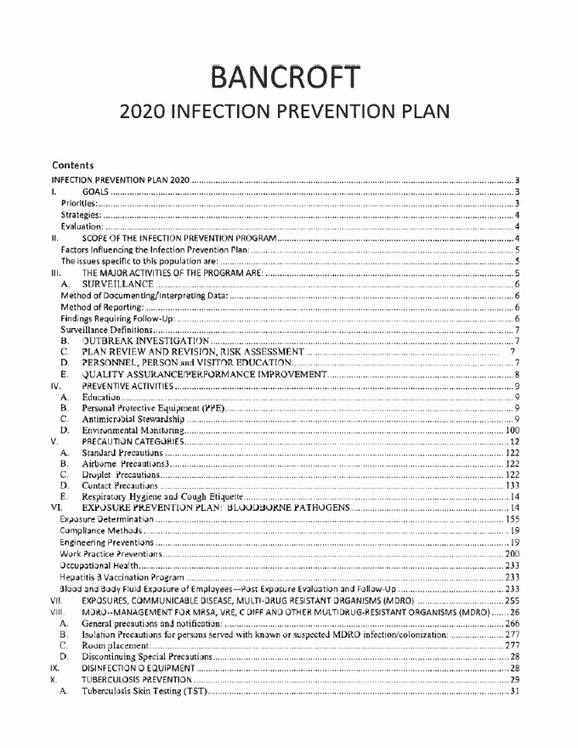



**APPENDIX D**

**BANCROFT SCHOOL**

**Weekly Student Contact Form**

**Student Name:**

**Teacher Name:**

**School District:**

**Week of:**

**Teacher/Parent Contacts:** *Record contacts and attempts*

| **Date & Time** | **Who you spoke to** | **Discussion pieces** |
| --- | --- | --- |
|  |  |  |
|  |  |  |
|  |  |  |
|  |  |  |
|  |  |  |

**Teacher/Student Contacts:** *Record student observations, student contact, & interactive activities*

| **Date & Time** | **Type of Interaction** | **Notes & Progress** |
| --- | --- | --- |
|  |  |  |
|  |  |  |
|  |  |  |
|  |  |  |
|  |  |  |

**Clinician Contacts:** *Clinicians contacts & attempts; summarize conversation*

| **Date & Time** | **Clinician & Title** | **Who you spoke to** | **Discussion pieces** |
| --- | --- | --- | --- |
|  |  |  |  |
|  |  |  |  |
|  |  |  |  |
|  |  |  |  |
|  |  |  |  |

**Additional Contact by LEA/School:** *Administrators, Packet Mailings etc; includes attempts*

| **Date & Time** | **Name & Title** | **Type of Contact/Discussion Pieces** |
| --- | --- | --- |
|  |  |  |
|  |  |  |

**Student Progress Notes:** *Please note relevant progress on instructional or related service goals*

| **IEP Goal or Objective** | **Reported By** | **Weekly Progress** | **How Was this Assessed** |
| --- | --- | --- | --- |
|  |  |  |  |
|  |  |  |  |
|  |  |  |  |
|  |  |  |  |
|  |  |  |  |
|  |  |  |  |
|  |  |  |  |

**Additional Notes:** *Any anecdotal notes of information*

**APPENDIX E**

Early Education Data Collection Forms

| Bancroft Early Education Program | | | | | |
| --- | --- | --- | --- | --- | --- |
| Incidental Teaching Data Sheet | | | | | |
| Name: Student Name | | | Program: Directions | | |
|
|  |  |  |  |  |  |
| * Fill in the date and your initials each time you work on the skill with the student. Indicate if the goal was prompted (P) or independent (I) | | | | | |
|
|
| Date |  |  |  |  |  |
| Initials |  |  |  |  |  |
| Prompt |  |  |  |  |  |
| Comment |  |  |  |  |  |
|
|  |  |  |  |  |  |
| Date |  |  |  |  |  |
| Initials |  |  |  |  |  |
| Prompt |  |  |  |  |  |
| Comment |  |  |  |  |  |
|
|  |  |  |  |  |  |
| Date |  |  |  |  |  |
| Initials |  |  |  |  |  |
| Prompt |  |  |  |  |  |
| Comment |  |  |  |  |  |
|

| Bancroft Early Education | | | | | | | | | | | | | | | |
| --- | --- | --- | --- | --- | --- | --- | --- | --- | --- | --- | --- | --- | --- | --- | --- |
|
| Task Analysis Data Sheet | | | | | | | | | | | | | | | |
|
| Student: Student Name | | | Program: Objective | | | | | | Direction: Directions | | | | | | |
|
| P = prompted |  |  |  |  |  |  |  |  |  |  |  |  |  |  |  |
| I = independent | |  |  |  | |  |  |  |  |  |  |  |  |  |  |
|  |  |  |  |  |  |  |  |  |  |  |  |  |  |  |  |
|  |  |  |  |  |  |  |  |  |  |  |  |  |  |  |  |
|  |  |  |  |  |  |  |  |  |  |  |  |  |  |  |  |
|  |  |  |
|  |  |  |
| Step 1 | | |  |  |  |  |  |  |  |  |  |  |  |  |  |
|
| Step 2 | | |  |  |  |  |  |  |  |  |  |  |  |  |  |
|
| Step 3 | | |  |  |  |  |  |  |  |  |  |  |  |  |  |
|
| Step 4 | | |  |  |  |  |  |  |  |  |  |  |  |  |  |
|
| Step 5 | | |  |  |  |  |  |  |  |  |  |  |  |  |  |
|

**APPENDIX F**

Family Nursing Sample Letter

(to return after Pandemic Closing)

Date: ___________

Dear Parent or Guardian,

Welcome back to school! We are so excited to have students back in our classrooms and hallways. We have missed their smiling faces and their energy each and every day. In an effort to keep our Bancroft School community safe, we will be following the mitigation recommendations of our local health authorities, State authorities and the Federal Centers for Disease Control (CDC) in all phases of our school reopening.

We are requesting that all parents or guardians assist our school community in maintaining a safe, Pandemic-free learning environment by keeping your child home from school if they are experiencing any signs or symptoms of illness. Symptoms to monitor in school-aged children are fever, over 99.9F, cough, shortness of breath, difficulty breathing, vomiting or diarrhea, skin rash, sore throat, muscle aches, headache or change or loss of taste or smell. We ask that if your child displays these symptoms or a fever greater than 99.9F, that you keep your child home until fever and symptom-free for greater than 72 hours. Thank you in advance for your cooperation!

Please notify the school nurse at (856) 524-7327 if you are keeping your student home for Virus-like symptoms or if your student has been in close proximity to someone who has tested positive for Virus.

We will be instituting staff and student wellness screenings upon arrival to school each morning. If your child arrives at school ill or becomes ill while in school, you must have a plan in place to pick them up at school ***within one hour of nursing request*** for the safety and well-being of the student and their fellow classmates. Please alert your child’s emergency contacts of this request. This is extremely important in order to prevent prolonged exposure within our school community. Parents or guardians of children who are at increased risk of severe illness should discuss with their health care provider whether that child should stay home to prevent school and/or community spread of disease.

Please be assured that all staff have also been instructed to stay home when ill. All staff are also required to practice frequent, thorough hand washing and proper respiratory etiquette throughout the school day. All staff (and students if required) will be encouraged to wear face coverings during the school day, though in some situations this may not be practical.

All students will be encouraged to wash their hands frequently. All school surfaces will be cleaned and disinfected frequently, employing intensive cleaning practices. Social distancing will be maintained whenever possible.

We want to reassure you that we will use the utmost caution as we re-open the Bancroft School. We look forward to working together with you to keep all of the children and our staff safe. I invite you to contact me at any time with any questions or concerns you may have at (856) 524-7327 or by email: carole.dascenzo@bancroft.org.

These are unusual times, but by adhering to strict preventative measures, a normal learning experience will be possible for your children. We will work together to achieve this!

Sincerely,

Carole D’Ascenzo, Certified School Nurse

cc: Executive Director, Principal

**APPENDIX G**

Symptom Tracker

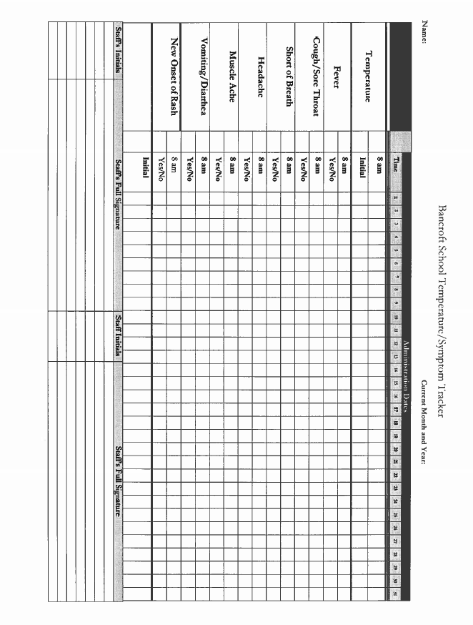

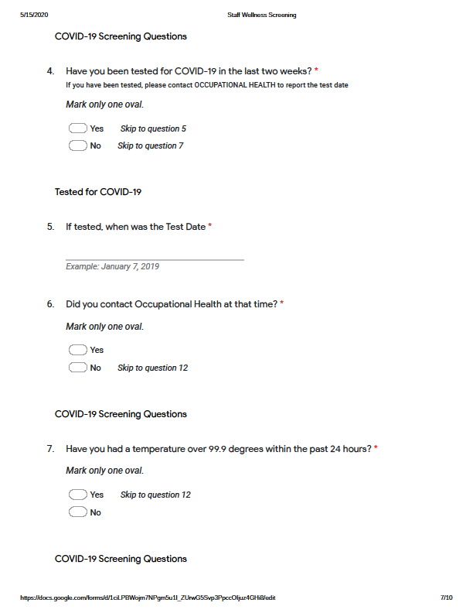

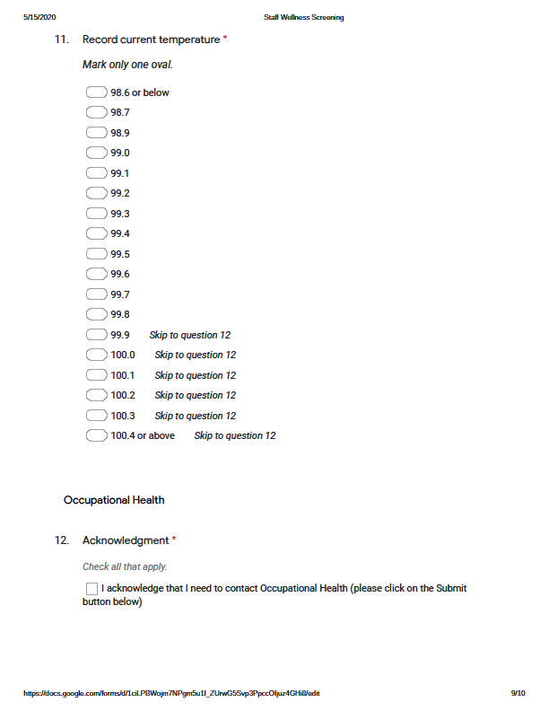

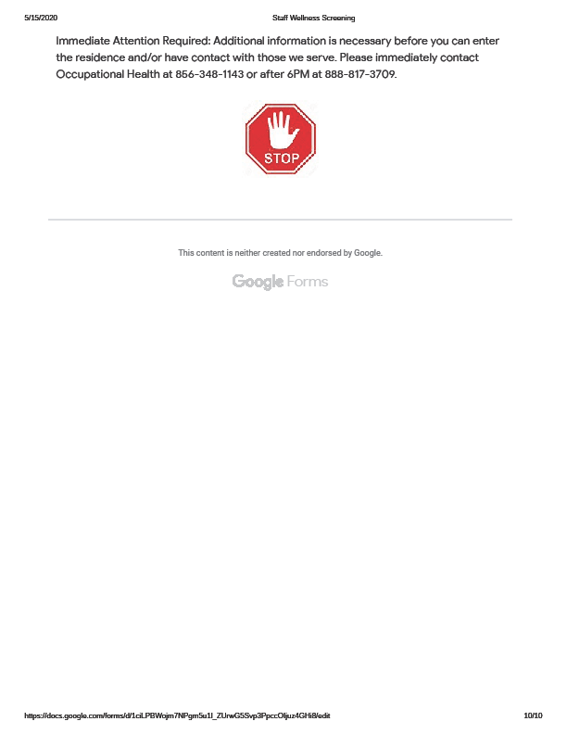

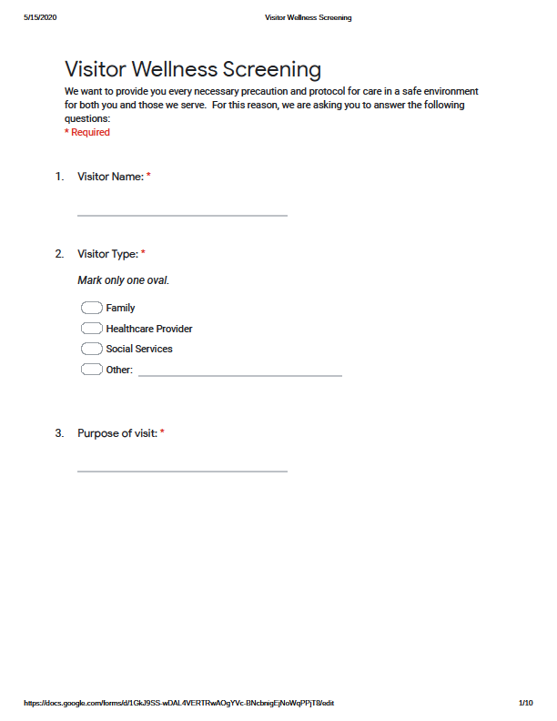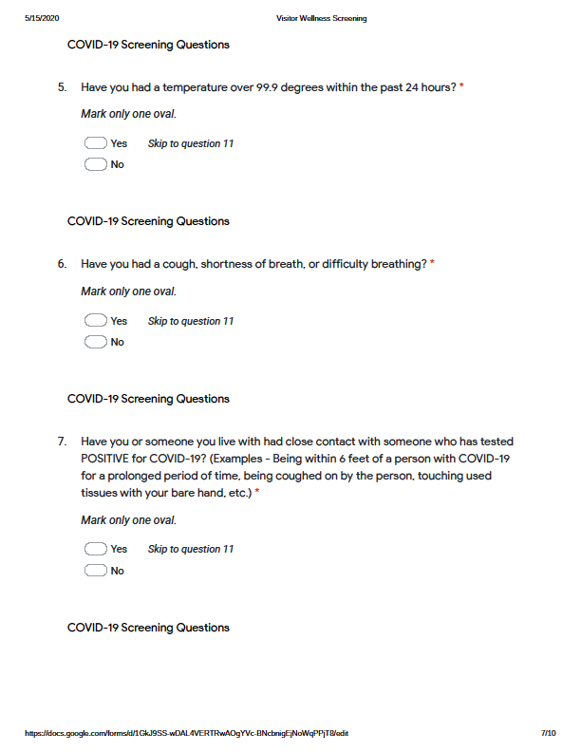

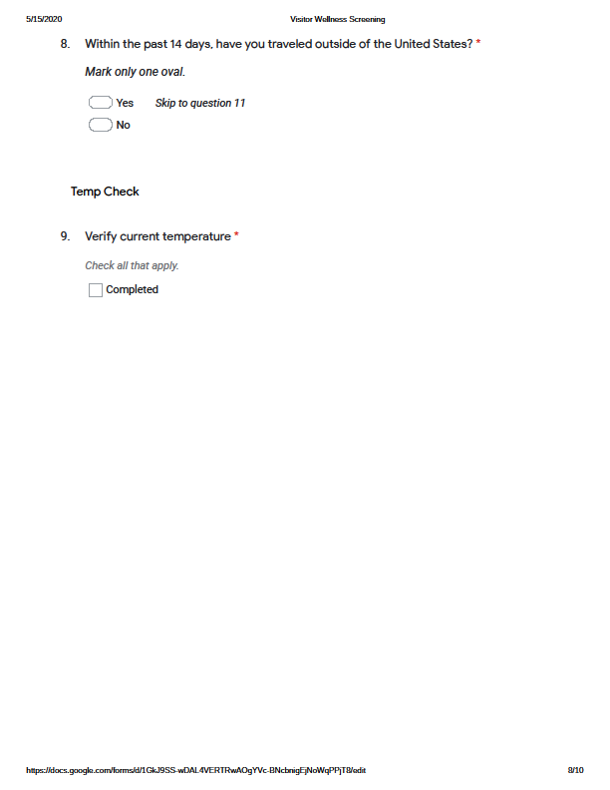

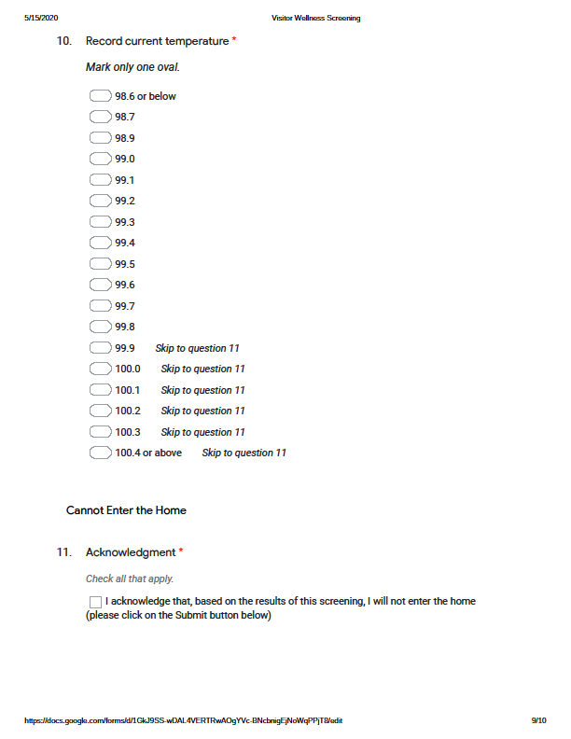

| **Early Education Program** | | | |
| --- | --- | --- | --- |
| **List of Essential Employees by Category** | **Role of Employee** | **Duties/ Work Stream** | **How Many Essential Employees Per Category** |
| **Administration** | Principal | Operations | **1** |
| **Administration** | Admin Assistant | Operations | 1 |
| **Maintenance** |  |  |  |
| **Custodial** |  |  |  |
| **Technology** |  |  |  |
| **Food Service Personnel** |  |  |  |
| **Food Service Personnel** |  |  |  |
|  |  |  |  |
| **Teachers** | **Hours per day** | **Remote** | **onsite** |
| 7 | 7 |  |
| Paraprofessionals |  |  |  |
| Therapists | 7 | 7 |  |
| Nurses |  |  | 1 |
| Ed Supervisor | 7 | 1 |  |

| **Bancroft at Voorhees Pediatric Facility** | | | |
| --- | --- | --- | --- |
| **List of Essential Employees by Category** | **Role of Employee** | **Duties/ Work Stream** | **How Many Essential Employees Per Category** |
| **Administration** | Principal | Operations | **1** |
| **Administration** | Education Supervisor | Coordinate schedules | 2 |
| **Maintenance** |  |  |  |
| **Custodial** |  |  |  |
| **Technology** |  |  |  |
| **Food Service Personnel** |  |  |  |
| **Food Service Personnel** |  |  |  |
|  |  |  |  |
| **Teachers** | **Hours per day** | **Remote** | **Onsite at VPF** |
| 7 | 14 |  |
| Paraprofessionals | 8 |  | 6 |
| Therapists | 8 |  | 8 |
| Nurses | 8 |  | 7 |

| BANCROFT SCHOOL and KOHLER ACADEMY  ESSENTIAL EMPLOYEES BY POSITION DURING SCHOOL CLOSURE: |
| --- |

TITLE ESSENTIAL

| Senior Director | X |
| --- | --- |
| Principal | X |
| Program Supervisors | X |
| Curriculum and Training Director | X |
| Teacher Leads | X |
| Teachers | X |
| Social Workers | X |
| Speech Therapists | X |
| Physical Therapists | X |
| Occupational Therapists | X |
| Behavior Analysts | X |
| Direct Support Professionals (1:1 aides) | X |
| Nurses | X |
| Business Manager | X |
| Administrative Assistants | X |
| Food Service Employees | X |
| Facilities Management | X |